Name: Angelina

My coding topic is to simulate a music app.
I would like it to sort songs into three categories. For example, sorted by artists, playing counts, and creating own playing lists.

Then, I create 6 main functions.
- Play songs
- See lists
- See artists
- Update lists (playcount, own playlist)
- Add songs
- Remove songs

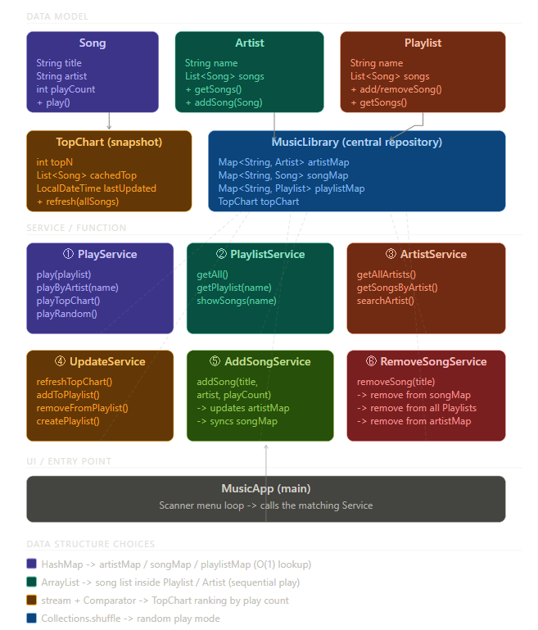

This is a flow chart made by claude.ai.

